Contestant Number: ____________________
Time: ___________________
Rank: _______________



PC SERVICING & TROUBLESHOOTING
(305)
NATIONAL 2021

CONCEPT KNOWLEDGE:

Multiple Choice (50 @ 2 points each) (100 points)

TOTAL POINTS (100 points)

Test Time: 60 minutes

GENERAL GUIDELINES:
Failure to adhere to any of the following rules will result in disqualification:
- Contestant must hand in this test booklet and all printouts if any. Failure to do so will result in disqualification.
- No equipment, supplies, or materials other than those specified for this event are allowed in the testing area. No previous BPA tests and/or sample tests (handwritten, photocopied, or keyed) are allowed in the testing area.
- Electronic devices will be monitored according to ACT standards.

- Which tool would you use to test a 24-pin ATX 12v power connector?
- Torx wrench
- Multimeter
- Receptacle tester
- Tone and probe kit

- HostA and SwitchA can successfully ping HostB and SwitchB.
Which of the following statements is correct regarding default gateways on this network?

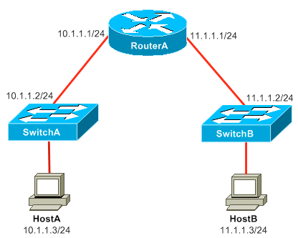C

- The IP address 10.1.1.3 /24 is the default gateway for SwitchA.
- The IP address 11.1.1.1/24 is the default gateway HostA and HostB
- The IP address 10.1.1.1/24 is the default gateway for HostA and Switch A
- The IP address 11.1.1.1/24 is the default gateway for SwitchA and SwitchB

- You are designing a small network that includes 20 workstations and three servers. You want to connect each of the devices together so that each device can use the most available bandwidth for least cost. Which of the following network devices should you use?
- Switch
- Hub
- Router
- Repeater

- Which one of the address below does not represents a valid host IP address?
- 192.168.2.32 /26
- 192.168.2.28 /27
- 192.168.4.127 /25
- 192.168.32.45 /28

- Which of the following translated MAC addresses to IP addresses?
- ARP
- RARP
- UDP
- TCP

- Which of the following best describes a hub?
- It is a device that divides a single broadcast or collision into multiple domains.
- It is a device that divides a single collision domain into multiple collision domains.
- It is device that forwards all received data from all ports except the port that originally received it.
- It is a device that extends a network segment while performing MAC address filtering.

- Which of the following CIDR subnet masks is equivalent to the 255.255.252.0 decimal subnet mask?
- /28
- /30
- /22
- /23

- Which of the following ports should you block if you want to prohibit Telnet traffic?
- 21
- 22
- 23
- 24

- Which layer of the TCP/IP model makes up the top three layers of the OSI model?
- Application Layer
- Transport Layer
- Network Access Layer
- Internet Layer

- Which of the following subnet masks contain 4,094 valid host addresses?
- /22
- /21
- /23
- /20

- You have been asked to configure Router A to function as a DHCP Server for a number of devices attached to it Fa0/1 interface. You have been asked to exclude five address from the DHCP pool that will be configured on RouterA
You issue the show running-config command to verify the subnet mask configured for the Fa0/1 interface on RouterA. Sample output from the relevant section of the running configuration of RouterA is displayed below:

Interface FastEthernet 0/1
Ip address 10.1.1.132 255.255.255.224
What is the maximum number of host addresses that this DHCP pool could accommodate?
- 32
- 25
- 20
- 30

- Which of the following types of addresses are handled at the Data Link Layer of the OSI model?
- Logical addresses
- MAC addresses
- Physical addresses
- IP addresses

- Which router or routers provide clocking?
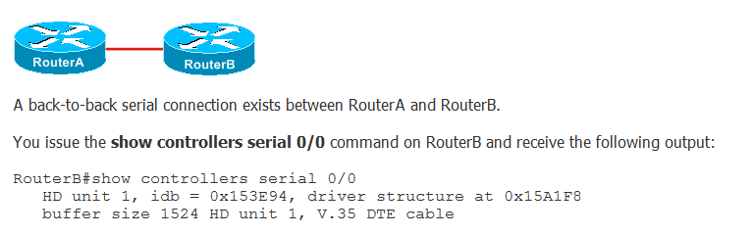
- Both Routers
- RouterB
- RouterA
- Neither Router, non is needed

- Which of the following commands should you issue to remotely connect to RouterB?

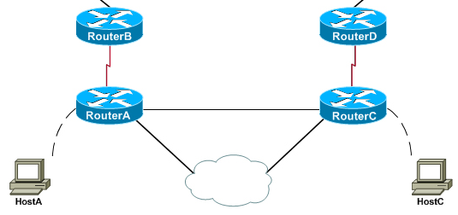
- telnet
- login
- tracert
- ping

- Given a host IP address 48.25.24.71 /21, what is the last available host address in this network?
- 48.25.24.254
- 48.25.24.127
- 48.25.31.254
- 48.25.24.255

- Which of the following addresses is reserved for diagnostic testing purposes of a NIC?
- 10.0.0.1
- 224.0.0.1
- 255.255.255.255
- 127.0.0.1

- Our company is opening a branch office that will contain 45 host computers. Your company has been allocated the 192.168.10.0/24 address range, and you have been asked to conserve IP address space when creating a subnet for the new branch office. Which of the following network addresses should you use for the new branch office?
- 192.168.10.64/27
- 192.168.10.80/27
- 192.168.10.80/28
- 192.168.10.32/26

- A user wants to use a laptop to display a presentation on a large TV monitor that has an HDMI connection. Which of the following laptop ports or connections can be used to add this display device?
- USB port using a USB-to-HDMI adapter
- USB port using a USB-to-Wireless dongle
- USB port using a USB-to-RJ45 dongle
- Expresscard connection using a Ethernet adapter

- Which component lets you use a notebook system as a desktop system by making it possible to connect a normal sized external mouse, keyboard and monitor?
- USB ports
- Built-in Bluetooth
- Docking station
- Firewire ports

- A company’s employee receive payment for their services using a credit card reader that physically attaches to an Apple mobile device. Which of the following connection types is being used?
- IR
- Bluetooth
- Lighting
- NFC

- A technician is tasked with configuring a mobile device to connect securely to the company network when the device is used at off-site locations where only internet connectivity is available. Which of the following should the technician configure?
- Hotspot
- Bluetooth
- IMAP
- VPN

- A company is considering providing smartphones to their employees and is investigating the interaction of the phones with iTunes, iCloud, Google Drive, Dropbox, and OneDrive. Which of the following data synchronization methods is being considered?
- Synchronization to the desktop
- Synchronization to the cloud
- Mutual authentication for multiple services
- Synchronization connection types

- When installing a new wireless router in a newly started small business, what should the technician do first?
- Press the WPS button
- Adjust the radio power levels
- Disable SSID broadcast
- Change the router’s default password

- As part of the configuration of a newly install smart home control system A technician should enable what feature so that the home owners can access the system remotely.
- DHCP
- QoS
- NAT
- Port forwarding

- You want a storage device that has the ability to integrate data and device power into a single cable, which of the following SATA devices is the best to use?
- eSATA
- STAT2
- STATA3
- eSATAp

- A customer is concerned about losing data due to a hard disk failure. The computer will only support a maximum of three disks. To protect the data, you have decided to use RAID. Which of the following RAID types would give the customer the best mirrored data protection?
- RAID 0
- RAID 1
- RAID 5
- RAID 10

- What is the advantage of using RAID 5 over RAID 1?
- RAID 5 provides redundancy; RAID 1 does not
- RAID 5 improves performance over RAID 1
- RAID 5 continues to operate with a failure in two disks; RAID 1 can oly operate with a failure of one disk
- RAID 5 provides redundancy for the disk controller

- To optimize the system performance, a technician would use which command line utilities to realign the systems file structure.
- Disk Management
- Fdisk
- Chkdsk
- Defrag

- A customer wishes to safely dispose of files from their computer systems. A technician should use which of the which disk management utilities to accomplish this task?
- Disk Management
- Disk Defragmenter
- Check Disk
- Disk Cleanup

- Your current hard drive has run out of disk space. The disk has been upgraded to a dynamic disk C:\ volume. You are adding a new hard disk to the system. Which step will complete the job while adding space to the C:\ drive?
- Span the C:\ Volume
- Create a mount point using space on the newly installed drive
- Strip the C:\ volume on the newly installed drive
- Copy the information to the cloud and reformat the initial drive

- How do you change your default printer to Dell_LaserJet?
- Printer>right click Dell_LaserJet>set as default
- Printer>remove all printer except Dell_LaserJet
- Device Manager>Printers>Enable Dell_LaserJet
- Device Manager>Ports>Mat to Dell_LaserJet

- What should the first step when troubleshooting a customer’s computer system?
- Check all log files for error messages in the system
- Communicates with the customer about the problems
- Check the AC power outlet voltage
- Format and reinstall the operating system

- Which of the following can be used to determine the location of a particular wire in a bundle of wires?
- Wire stripper
- Tone generator
- Multimeter
- Crimpers

- The company has network printer that are attached to the business network. All the workers can print but are unable to reach the internet? What can the technician do to resolve the problem?
- The PC’s default gateway address is missing or incorrect
- The PC’s have an incorrect IP address scheme
- The network switch cable connection to the PC’s are faulty
- The PC’s NIC cards are faulty

- The network technician recently installed fiber-optic cables adjacent to the fluorescent lights, what situation might be experienced?
- Lighting problems
- Poor network performance
- Better performance
- No adverse effects

- A computer needs to be configured with a static IP address to gain access to the network and the Internet. What information is needed to accomplish this task?
- Subnet mask, Home page, FQDN, WINS server
- IP address, DNS, IPX/SPX, TSR
- IP address, Subnet mask, Gateway address and DNS
- IP address, Subnet mask, Gateway address and NetBIOS name

- You are a network administrator and you need to configure workstations which are not part of a Windows domain. Management does not want their employees to download applications from the Windows store. How would the network administrator enable a policy that turns off the store application for all users on the workstations?
- Control Panel
- Local Group Policy Editor
- Windows Firewall
- Computer Management

- When connecting a laser printer directly to a Windows computer system, how would employees on the same network be able to send print jobs to this printer?
- Configure the printer to be a print server
- Configure the workstations as a print driver
- Configure the printer to be a shared printer
- Give the printer an IP address that is on the same network

- What is an unsolicited e-mail message sent to many recipients?
- Adware
- Cookies
- Spam
- Spyware

- Which tool is used to terminate wires at a patch panel?
- Tone generator
- Cable plunger
- Crimpers
- Punch down tool

- Which term describes two-way simultaneous communications?
- Half Duplex
- Simplex
- Full Duplex
- Complex Communication

- What problem would be experienced by a failing DNS server?
- Firewall failure
- No access to URL’s using domain names
- No network connections
- No access to URL’s at all

- Using CAT 5e/6 UTP cable, what is the maximum cable distance between a computer system NIC and the network switch?
- 100 feet
- 100 meters
- 300 feet
- 300 meters

- When using remote connections what protocol is used to add security?
- SSH
- HTTP
- FTP
- NetBEUI

- Which protocol is used to automatically assign IP address and other IP information to workstations on the network?
- TENET
- DNS
- TFTP
- DHCP

- According to the troubleshooting theory, what should you do after you have established a theory of probable cause?
- Establish a plan of action to resolve the problem
- Test the theory to determine the cause
- Document finding, actions and outcomes
- Identify the problem

- What should be avoided when communicating with an end user to solve a problem?
- Use complex acronyms and computer terminology
- Clarifying customer statements
- Maintain a positive attitude in difficult situations
- Listen to customer

- Which of the following is a secure web site?
- Html://www.secure.ibm.net
- www.microsoft.net
- http://www.veryfine.com
- https://www.schwab.com/login

- Which type of server would you need to send e-mail messages?
- POP3 Server
- DHCP Server
- SMTP Server
- SNMP Server

- Which command shows a network adapter’s physical address?
- telnet/all
- tracert/all
- ping/all
- ipconfig/all

